User Training Manual – Accounts Receivable

Prepared for

**Technica International**

Version: **2.0**

Prepared by:

Mohanad Kamal

Mahmoud Karim

Contributors:

Jocelyne Moussa

Table of Contents

01.

Introduction

02.

Accounts receivable configuration

03.

Accounts receivable processes

04.

Accounts receivable reports

|  |
| --- |
| CONTENTS |

**INFO-SYS| TRAINING DOCUMENT** **01**

|  |
| --- |
| INTRODUCTION |

# Introduction

## Purpose

The purpose of this document is to provide guidance on managing customer-related financial transactions through the Accounts Receivable module in Microsoft Dynamics 365 Finance and Operations. It explains how to record, track, and control customer invoices, receipts, and credit notes to ensure accurate financial reporting and efficient collection of receivables.

## Scope

This document covers the complete lifecycle of customer transactions, including customer creation and maintenance, project advance payments and packing slip invoicing, free text invoicing, payment receipt processing, settlement, intercompany trade. It also includes reporting and inquiry functions for monitoring customer balances, overdue accounts, and aging analysis.

# Accounts receivable configuration

## Terms of payment

* Use the Terms of payment form to define all the terms of payment that the company and its customers use. You can also use a term of payment to calculate the due date based on the date of the invoice.

1. Accounts receivable > Payment setup > Terms of payment.
2. Click New to create a new term of payment.
3. In the Terms of payment field, enter a code or a short name for the term of payment.
4. Enter a descriptive name for the term of payment in the Description field.
5. Click the Setup Fast Tab.
6. In the Payment method list, select the method to calculate the due date.
   * 1. Select Net and enter the number of days in the Days field.
     2. Or select COD in case of cash on delivery payment term.

## Method of payment

* In the Methods of payment form, we specify all the methods of payment the company uses to receive payments from its customers. For each method of payment, enter information that states how payments should be posted.

1. Accounts receivable > Payment setup > Method of payment.
2. Click New to create a new method of payment.
3. Enter a name for the new method of payment in the Method of payment field.
4. Enter a description of the method of payment in the Description field.
5. Click the General Fast Tab.
6. In the Posting area in the Account type list, select the type of offset account that is used for payments (Ledger or Bank)
7. Select the liquidity account for payment in the Payment account list.

## Customer group

* In the Customer group form, at least one customer group must be set up, because a customer group must be specified when you set up a new customer.

1. Accounts receivable > Setup > Customer group.
2. Click New to create a new record.
3. Enter a short name for the customer group in the Customer group field. Use this name for the customer group anywhere in the system, whenever required to specify a customer group.
4. Enter the full name of the customer group in the Description field.

## Customer posting profile

* In Accounts Receivable posting profiles, the summary accounts are defined for customers. Summary accounts are temporary accounts where all invoices are posted and offset when the customer pays or all the prepayments are posted to and offset when the invoice is issued. Will assign a summary account to each group of customers in each posting profile.

1. Accounts receivable > Setup > Customer posting profile.
2. Select the posting profile.
3. Click the Setup Tab.
4. Click Add
5. Select “Group” in the Account code field
6. In the Account/Group number field, Select the Customer group to which the posting profile setup record relates.
7. In the summary account field, Select the account number of the ledger account that is used as the Customer’s summary account for the Customer group.

# Accounts receivable processes

## Customer creation

1. Sales and marketing > Customers > All customers > Click new

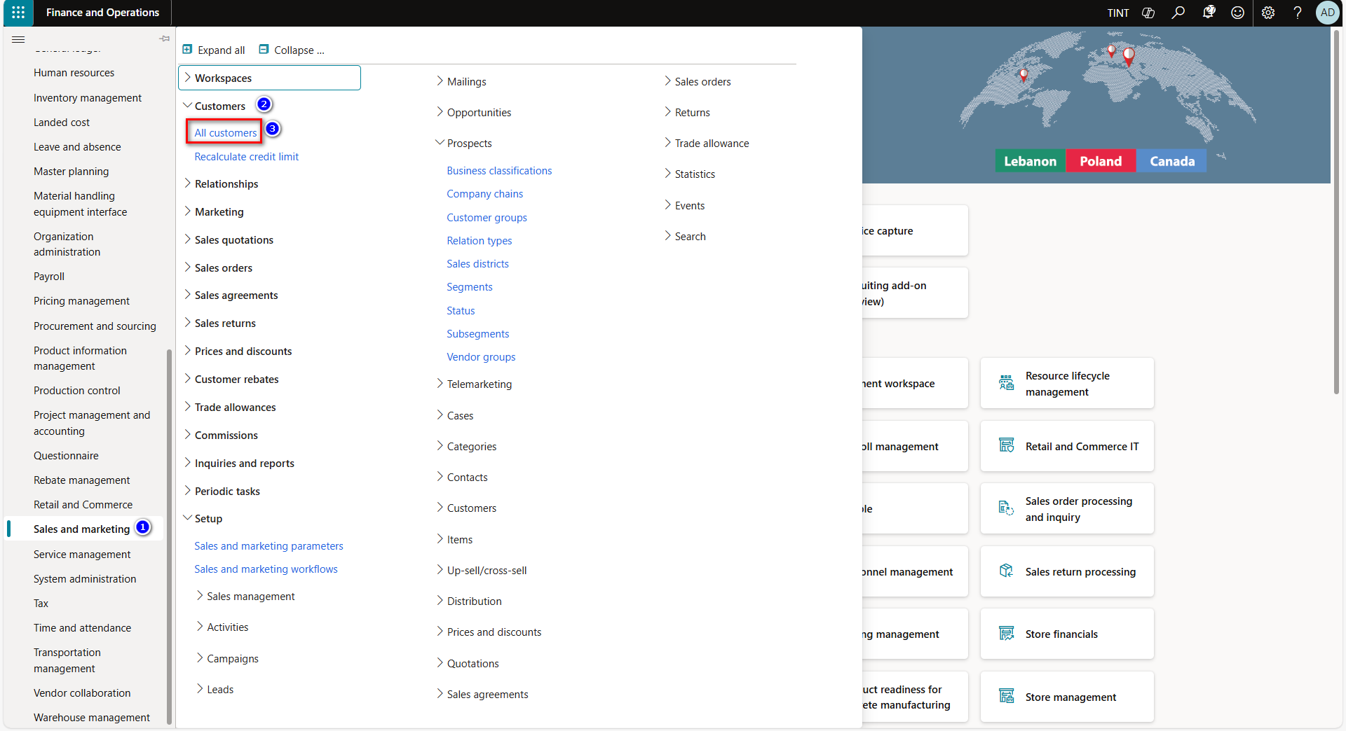

1. Record type: Select whether the customer is a person or an organization.
2. Enter customer name in Name field.
3. Select and assign the customer group in group field.
4. Select the currency of the customer. The currency that is automatically entered on invoices to the selected customer.
5. Select the terms of payment of the customer.
6. Select the sales tax group.
7. Select the country of the customer.

1. In the addresses fast tab, enter the customer’s address. You can enter multiple addresses for the same customer.
2. In the name or description enter the address description (head office for example)
3. In the purpose field, enter or select a value. You can select one or more purposes. These are used to select the correct address for a given purpose. For example, if the purpose is “invoice” that address will be used when you send invoices.
4. In the country/region field, enter or select a value. Enter the address details. The country/region that you selected will determine the fields you are presented with, corresponding to the address format for the country/region.
5. You can provide as many addresses as needed for the customer.
6. Click ok.

1. In the contact information fast tab provides the contact information of multiple stakeholders in the customer’s organization, you can also define the primary contact at the customer’s organization.
2. In the miscellaneous details fast tab indicate the following:

Country/region the customer belongs to.

Select the direct delivery checkbox if the customer’s sales orders are fulfilled using direct delivery.

1. In the credit & collections fast tab, specify the credit rating & credit limit of the customer. Also under credit and collections tab, you can specify/change the confirmation, delivery and invoicing on hold.

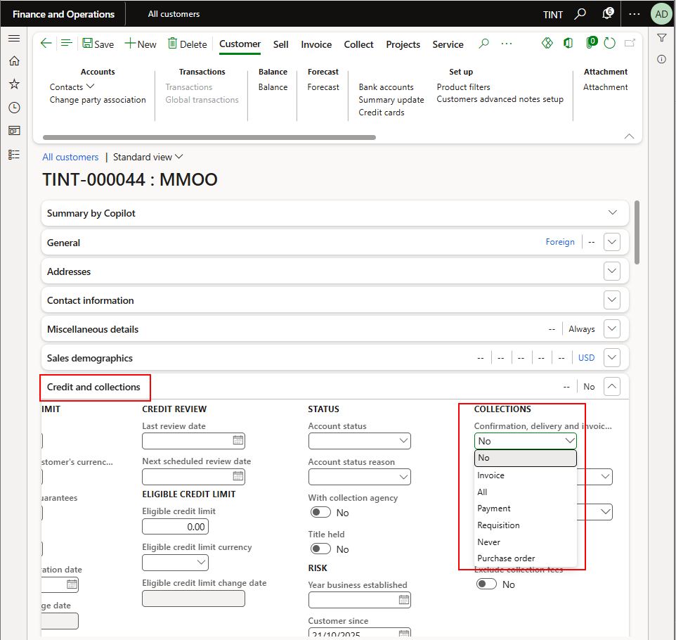

1. In the payment defaults fast tab define the following:

Terms of payment.

Method of payment.

Customer’s bank account.

1. In the invoice and delivery fast tab, specify the following:

Customer’s invoice account.

Delivery terms & mode of delivery used on customer transactions.

Sales tax group.

## Project Advance Payments

Navigate to Project management and accounting > projects > all projects

Select a project

Under manage > Bill. Select the on-account transaction

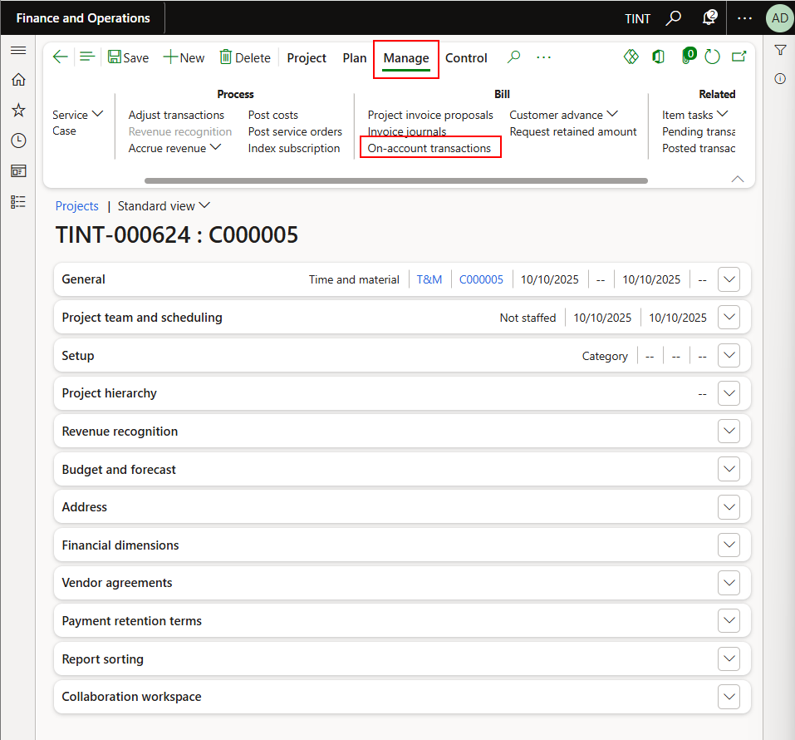

In the on-account transaction, check the field “mark as complete”. If it is ticked, you can go ahead and post the invoice proposal

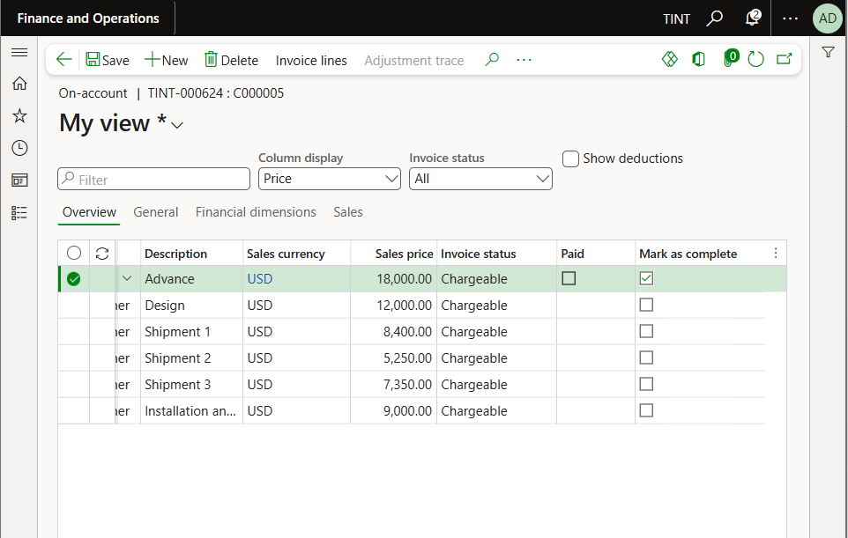

In case of negative or positive RCO, the project quotation will be transferred to the related project, the customer advances should be updated accordingly, and the system will validate the total of all related quotations versus the on-account invoices.

The new quotation amount will be updated automatically and the system will display the related quotations numbers.

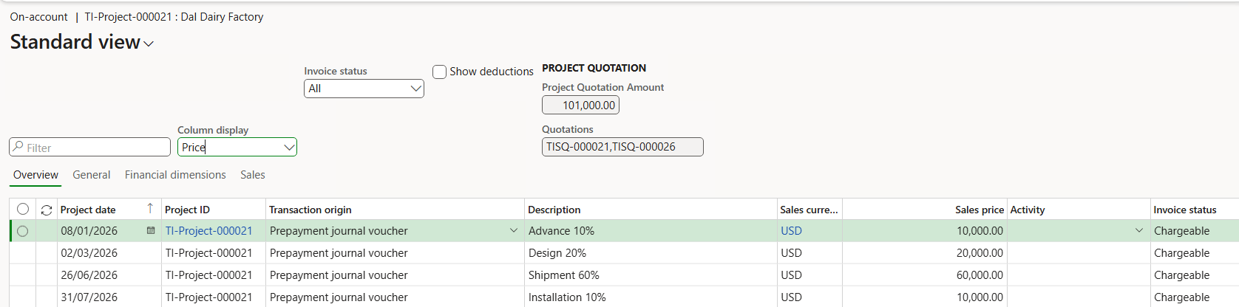

To post the invoice proposal, go back to the project. Under Manage > new. Select Invoice proposal

Clear the end date and then the on-account transactions will show. Select the needed transaction and click OK

When pressing OK, the invoice proposal screen will show. **Make sure to check/update the correct terms of payment and the correct posting profile. Post the invoice proposal.**

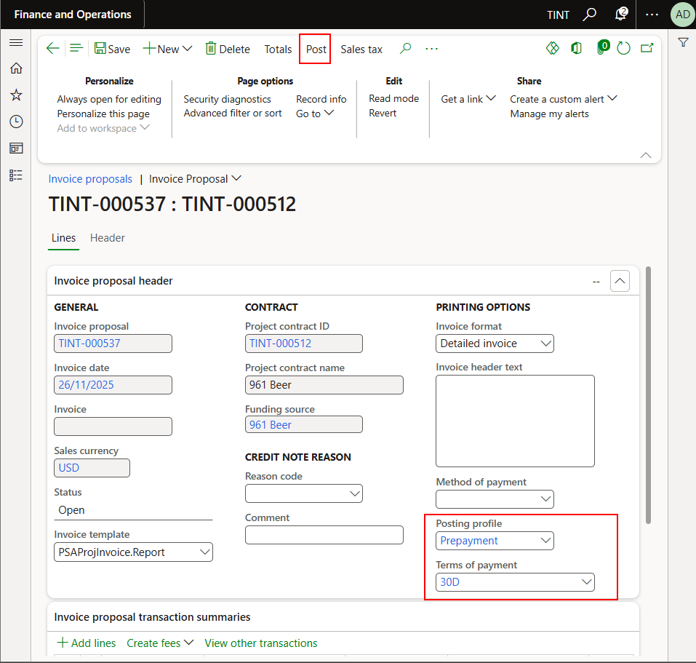

When posting the consequent advance payments, follow similar steps. Navigate to manage > new. Select invoice proposal

Clear the end date

Under project transactions, select the transaction you want to create an invoice proposal against.

**Under advances and deductions, ensure to clear the checkbox**

Make sure to specify the terms of payment and the posting profile (Prepayment) for the advance payment

Check the invoice proposal financial dimensions on the invoice proposal header

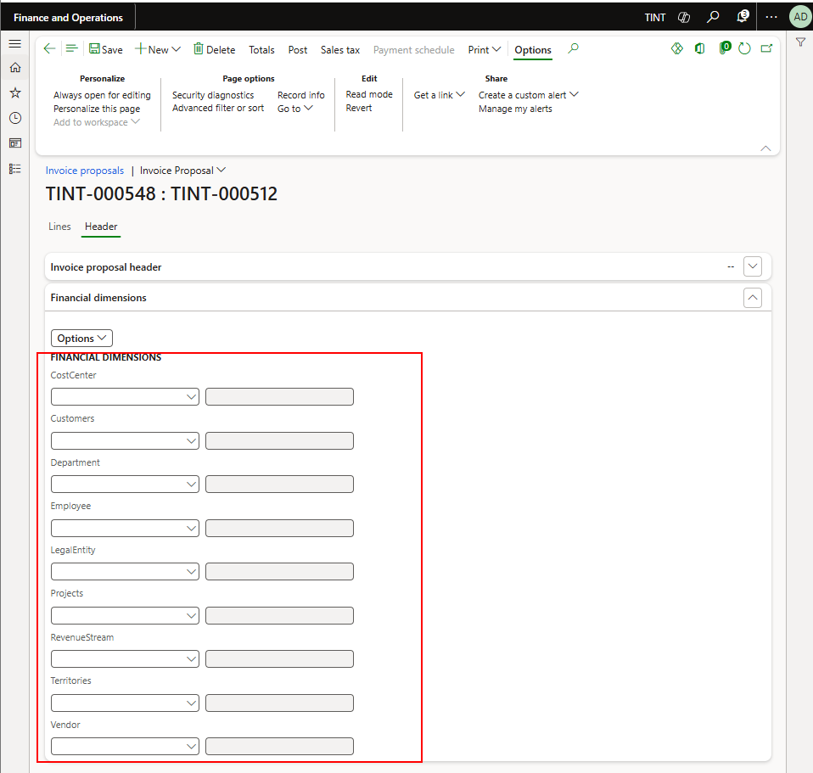



When processing a customer payment against the advance (Processing a customer payment is explained below) the PAID checkbox on the on-account transaction screen will be checked.

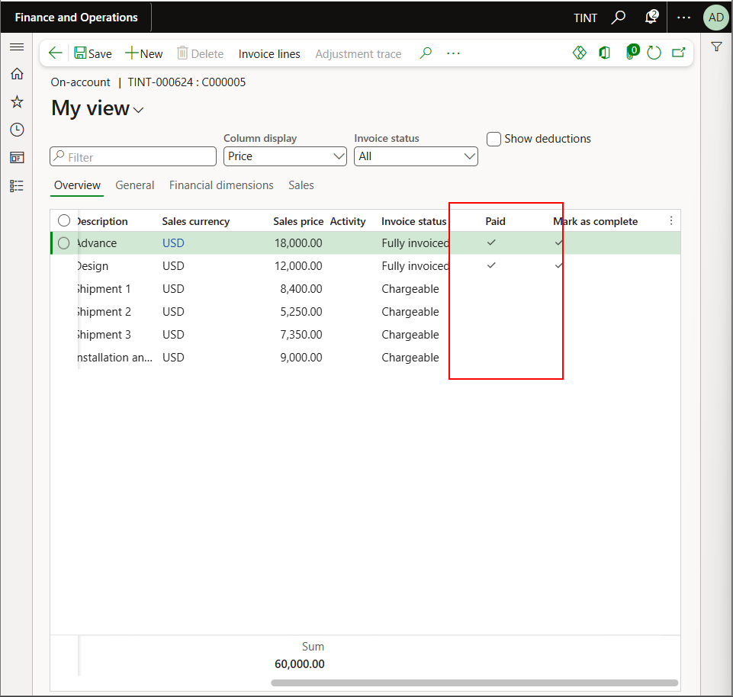

## Invoicing a packing slip

*Path: Project management and accounting > projects > all projects*

1. Select the project. Under manage > New > Invoice proposal

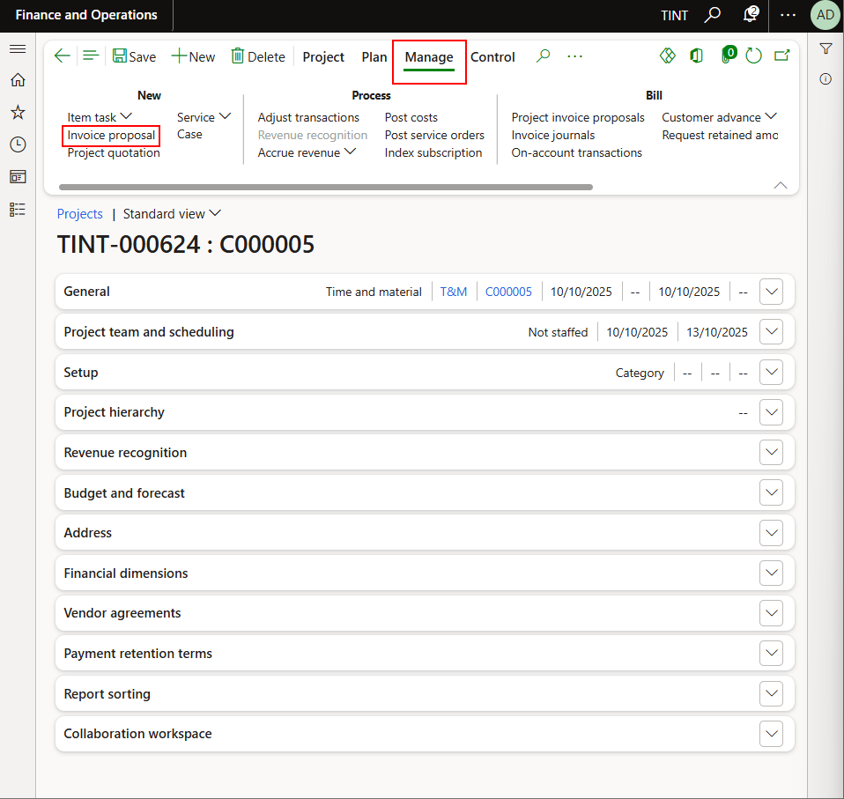

1. Clear the end date. Select the item requirement transaction origin under the project transactions

1. Under advance and deductions, select the invoiced advance payments to deduct from them; Use split amount to ensure to deduct the required value from the received advance.

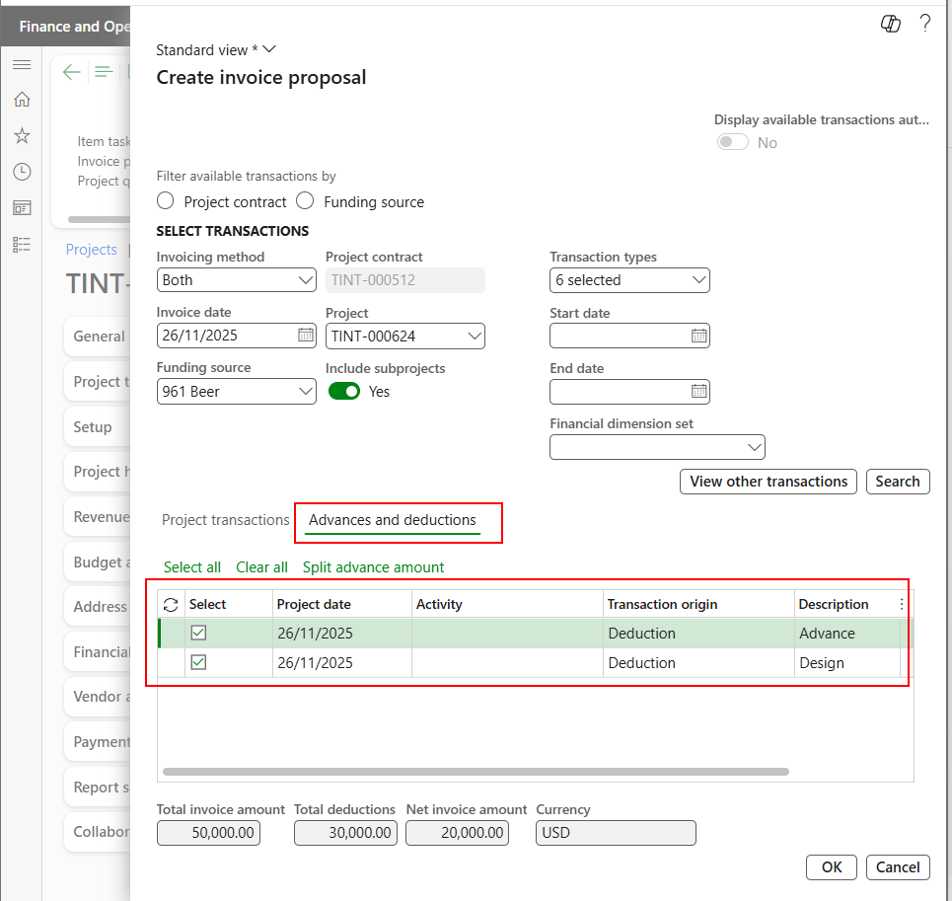

1. Click OK
2. In case of invoicing the packing slip, make sure to change the posting profile to “Shipment” and specify the terms of payment. Then select Post

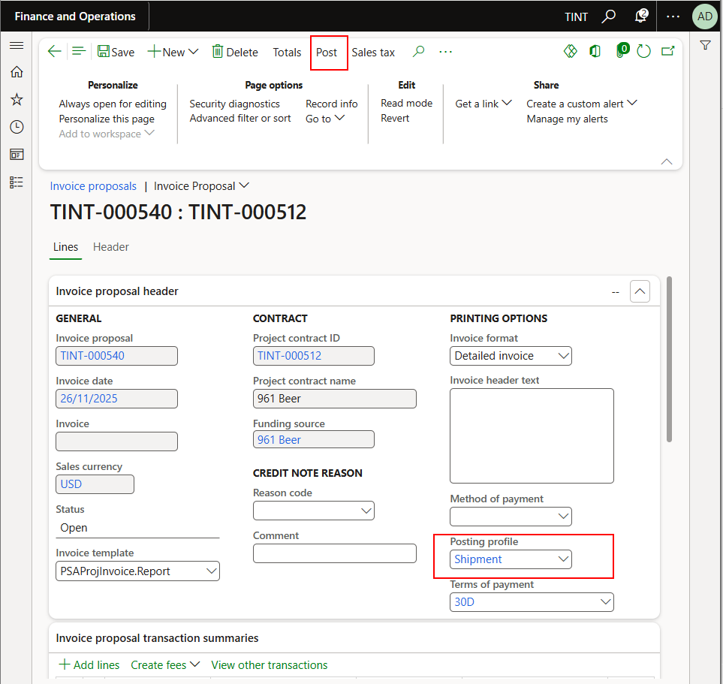

## Free text invoicing

Path: Accounts receivable > Invoices > all free text invoices

1. Click on New
2. Enter customer account, method of payment, terms of payment

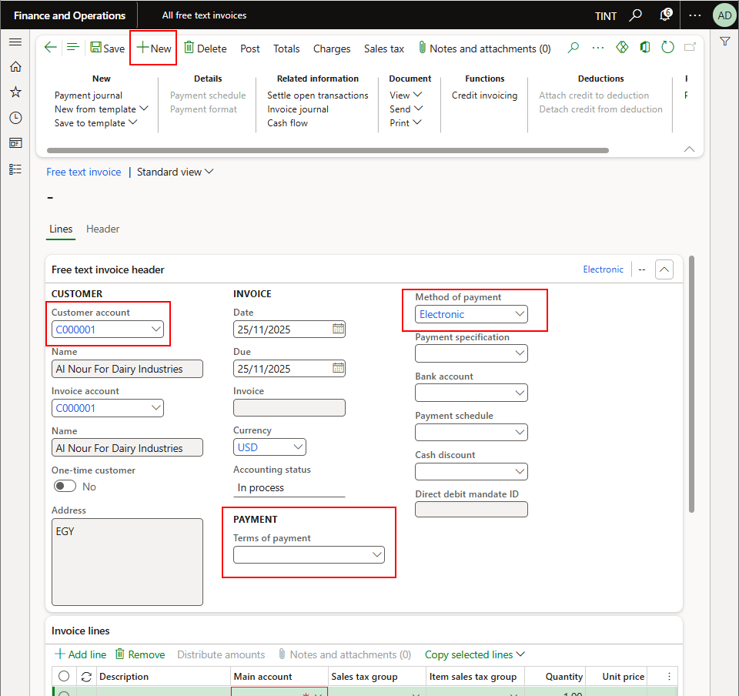

1. On the invoice lines specify the main account that will be affected.
2. Enter a description of sales tax group, quantity and unit price. If it is related to a fixed asset specify the fixed asset number.

1. Click on Post

## Customer payments

1. Accounts receivable > Payments > Customer payment journal.
2. Click New to create a new payment journal.
3. In the Name field, select the payment journal related to the customer payment’s method of payment.

1. Click lines to open journal lines.

1. Select the transaction date in the Date field.
2. Select the customer account in the Account field.
3. Enter description for the transaction in Description field.
4. Enter the payment amount in Credit field.
5. Select the currency in Currency field.
6. Select the payment method in Method of payment field.
7. Click on financial dimensions and then click on account and enter financial dimensions related to the customer account.

1. Click ok to close the form.
2. Click on financial dimensions and then click on offset account and enter financial dimensions related to the bank account (Financial dimensions might need to be updated in the Offset account field on the line directly if the offset account type field is set to ledger).
3. Click ok to close the form.
4. Click on settle transactions to link invoices related to this payment (Settlement can be done later from Customer’s form directly if needed).
5. Mark invoices for settlement and update amount to settle if required for partial payment.

1. Click OK.
2. Click Post.

## Settlement and undo settlement for customers transactions

1. Accounts receivable > Customer > All customers.

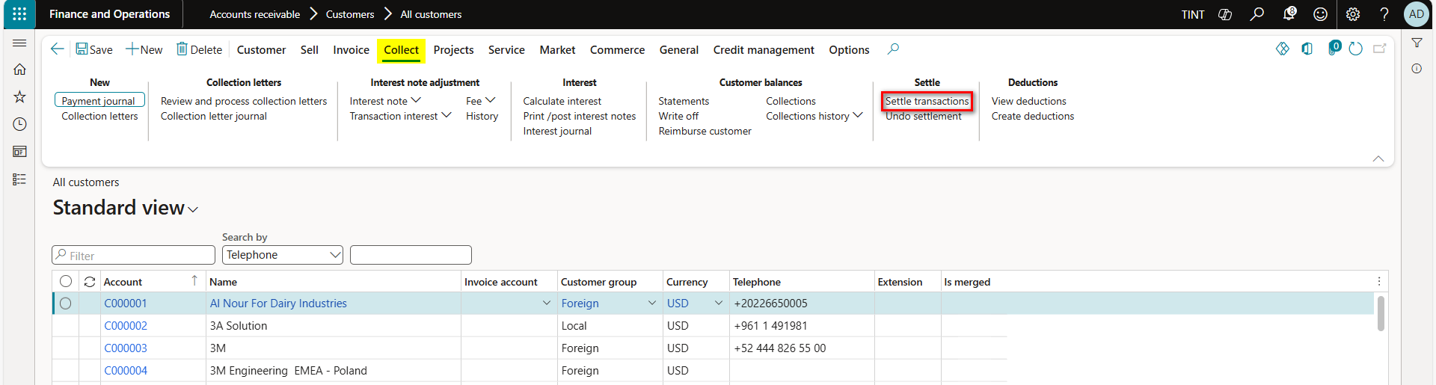

1. Click on Settle transactions to link posted payments (Prepayment) to invoices.
2. Mark on the payment line and invoice line.
3. Click post.

1. Click on Undo settlement to reverse settlement between posted payment and invoice.
2. Mark on the payment line or invoice line.
3. Click Reverse.

## Reverse customer’s transactions

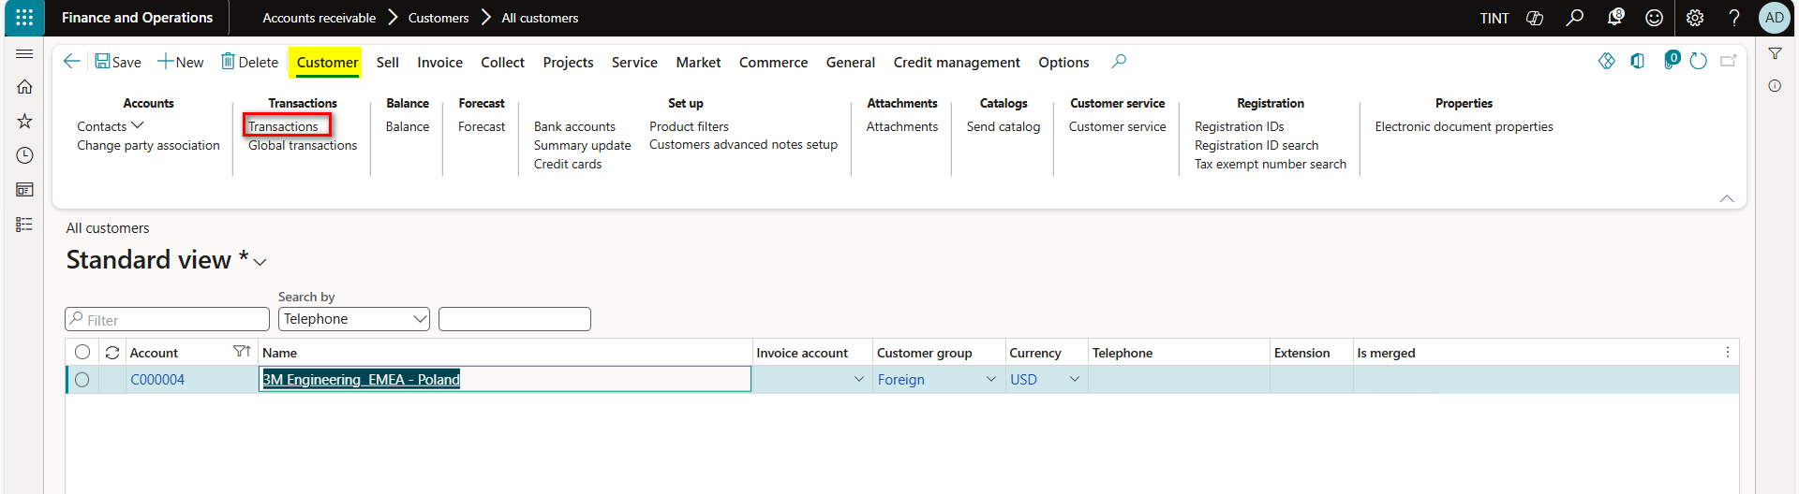

1. Click on Transactions.
2. Select the transaction needed to be reversed.
3. Click Reverse transaction.
4. Enter reversal date and click OK.

## Foreign currency revaluation

1. Accounts receivable > Periodic task > Foreign currency revaluation.
2. Click Simulation to view the revaluation result before processing it.
3. Enter the revaluation vouchers posting date in the Considered date field.
4. Enter exchange rate date in Date of rate field.

1. Click Ok.

1. Close the report viewer after reviewing it.
2. Click foreign currency revaluation for actual posting.
3. Enter the revaluation vouchers posting date in the Considered date field.
4. Enter exchange rate date in Date of rate field.

1. Click Ok.
2. Click on voucher to review posted voucher.
3. Click reviewed after reviewing the voucher (This will mark the transaction in the reviewed column).

## Intercompany trade operations

Path: Accounts receivable > customers > all customers

1. Select a customer
2. Under General > setup. Select intercompany

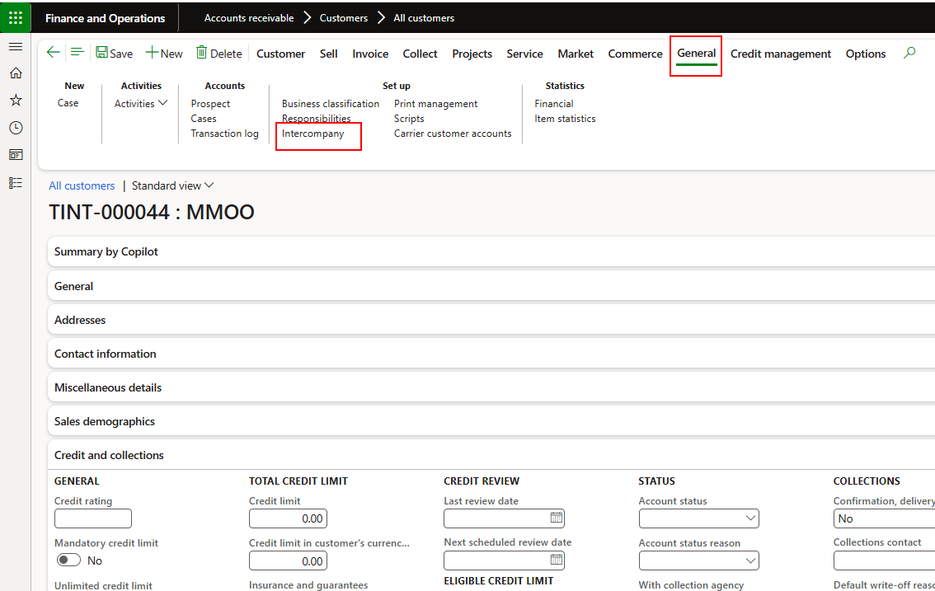

1. The intercompany dialogue will open
2. Switch to active and specify the vendor company with the vendor account in the other company.

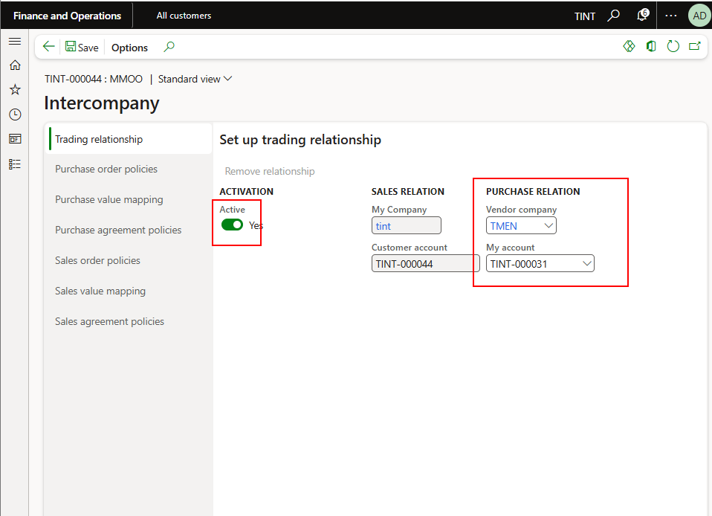

1. Specify sales order policies. Please note that the same applies for purchase order policies.

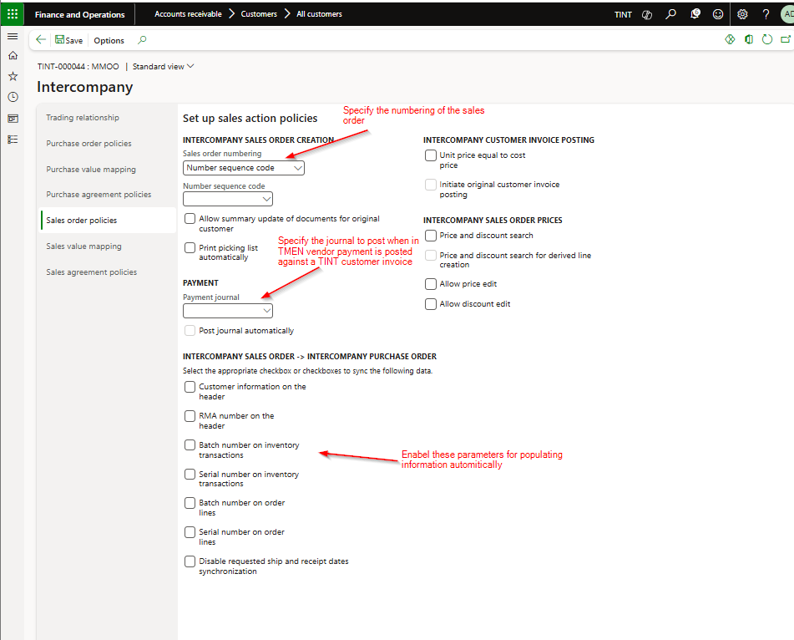

1. Ensure that the product used in the sales order in TINT is also available in TMEN with all the required configuration
2. To view the related orders, navigate the sales order and under general > related information > related orders

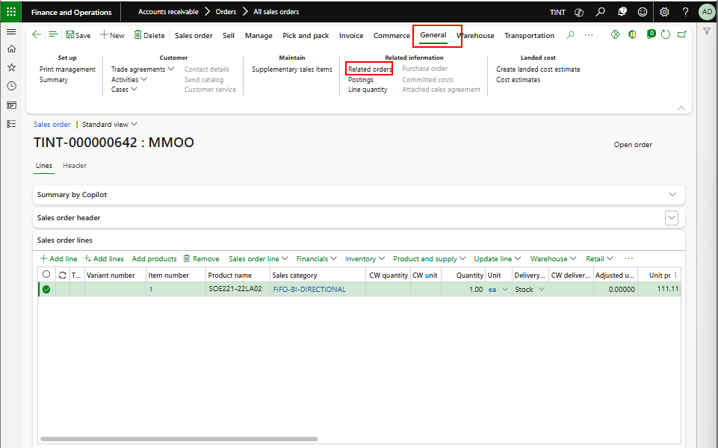

1. You will be able to see that an intercompany purchase order is created

# Accounts receivable reports

## Customer account statement report.

* Accounts receivable > Inquiries and reports > Customer reports > Customer account statement report.

## Customer aging report.

* The Customer Aging Report classifies outstanding customer balances according to aging periods (e.g., 0–30 days, 31–60 days, etc.)
* Credit and collections > Inquiries and reports > Customer report > Customer aging report.

## Aged Balances:

Aged balances report under the credit and collect module displays outstanding customer balances, segmented by aging periods (e.g., 0-30, 31-60, 60+ days). It allows for real-time, or snapshot-based analysis of overdue invoices,, helping organizations manage cash flow, assess, credit risk, and prioritize collection efforts.

Navigate to credit and collection Module >Collection > Aged Balances

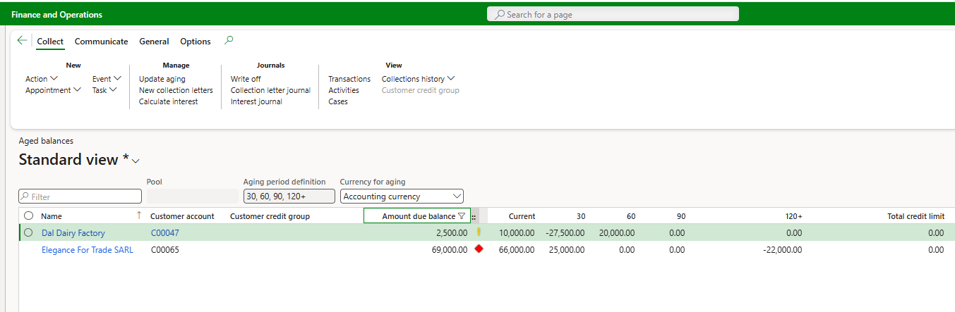

## Customer to Ledger Reconciliation

Customer to Ledger Reconciliation (referred to as Accounts Receivable reconciliation) is a vital month-end accounting process that ensures the total balance in the customer sub-ledger matches the corresponding AR control account in the General Ledger. This process validates that all individual customer transactions (invoices, payments, credit memos) have been accurately recorded and posted to the main financial records, ensuring accuracy in financial reporting and reducing audit risks.

Accounts receivable > Inquiries and reports > Customer reports > Customer to Ledger Reconciliation

